Ai assisted coding Assignment-11.1
Name:E.Srivarsha
Batch-44
HTNO:2303a52343
Task 1 – Stack Implementation
Task: Use AI to generate a Stack class with push, pop, peek, and is_empty methods.
Prompt:
Generate a Python class named Stack. It should implement push, pop, peek, and is_empty methods.Use a list internally. Add proper docstrings and comments. Handle empty stack conditions properly.
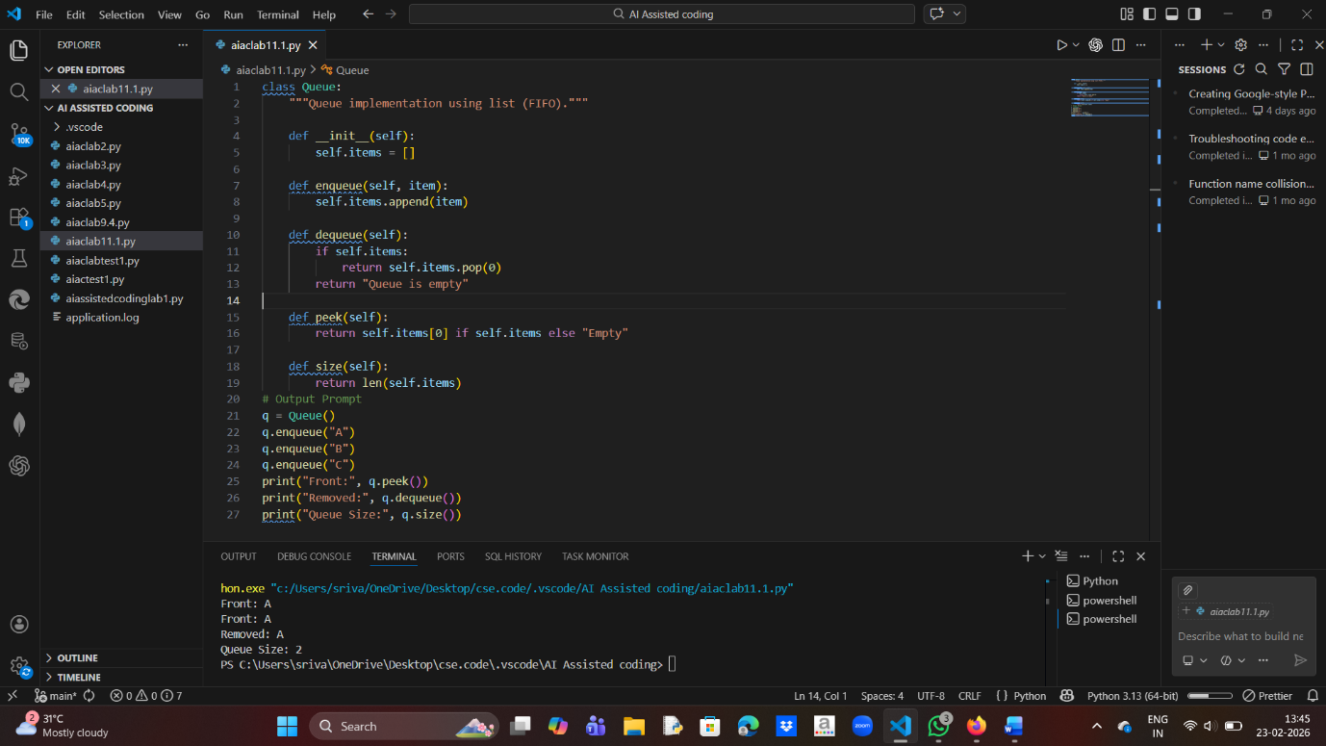

Task 2 – Queue Implementation
Prompt: Generate a Python Queue class using list. Implement enqueue, dequeue, peek and size methods. Follow FIFO principle. Add docstrings and handle empty conditions.
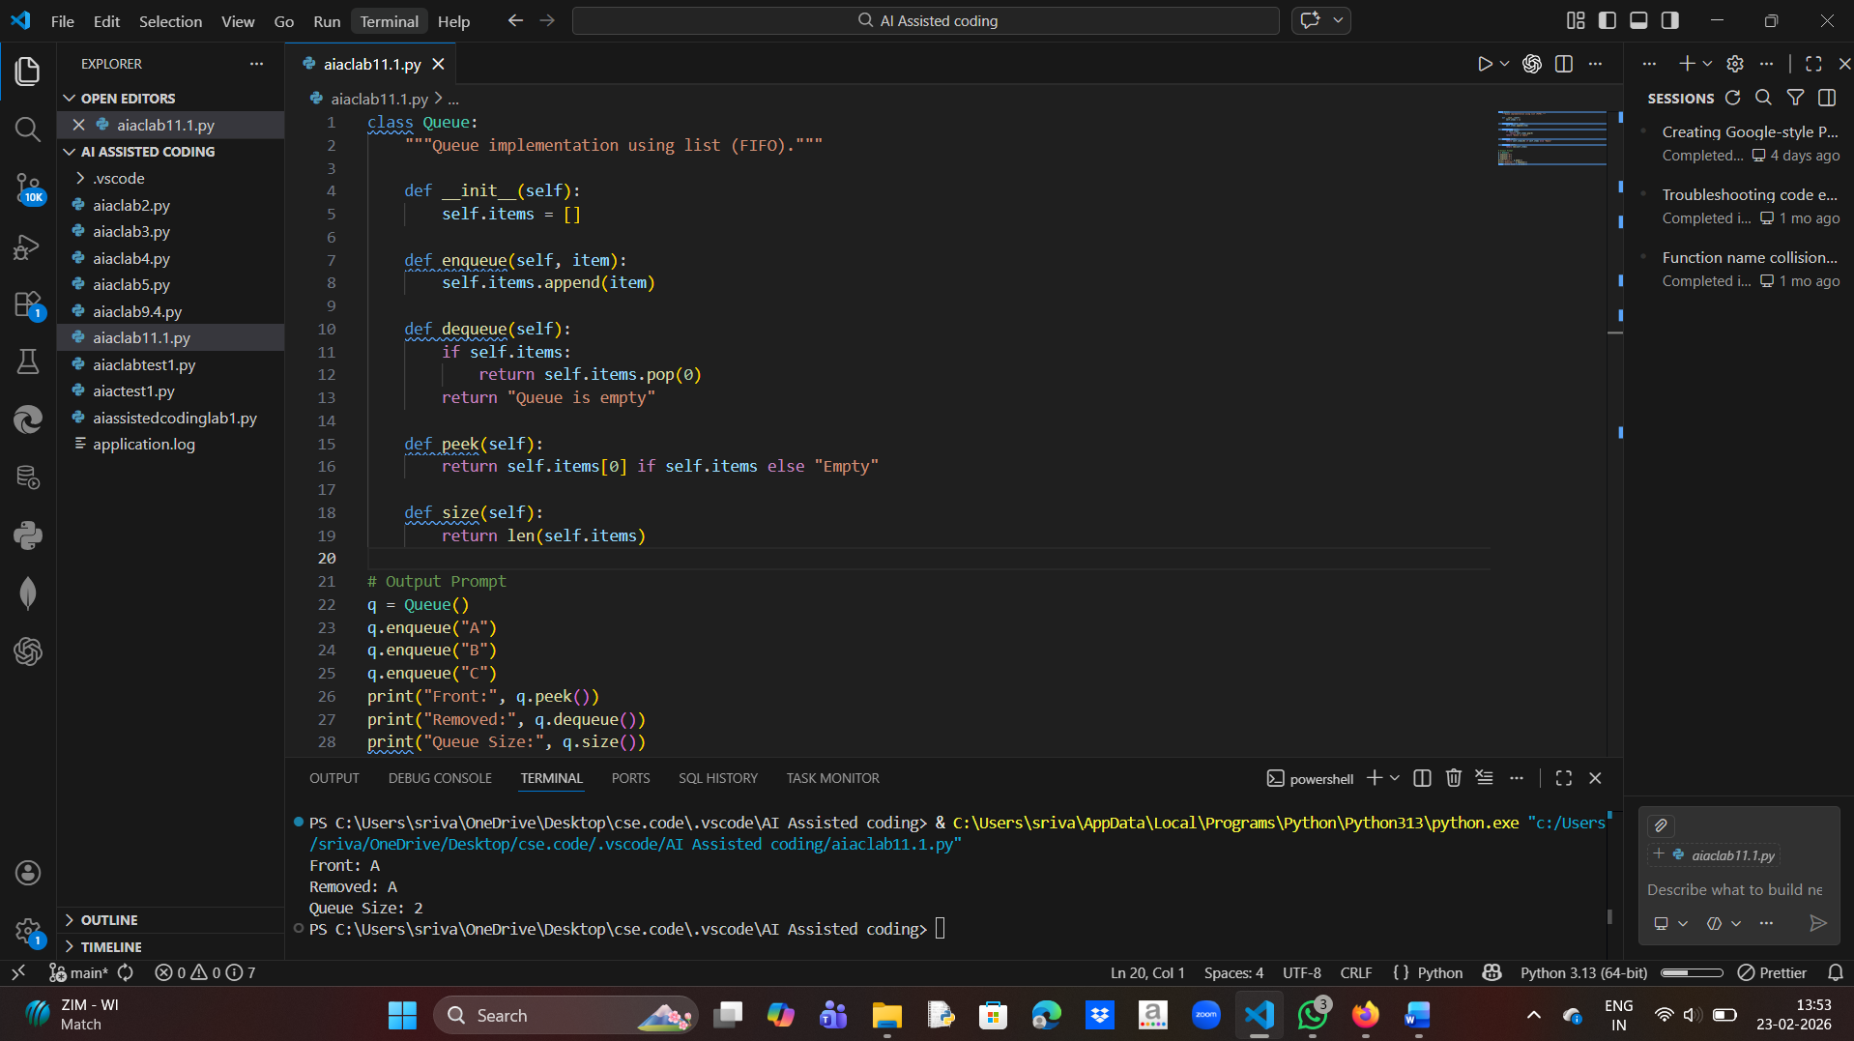

Task 3 – Linked List
🔹 Prompt:
Generate a Singly Linked List in Python with Node class. Include insert and display methods.
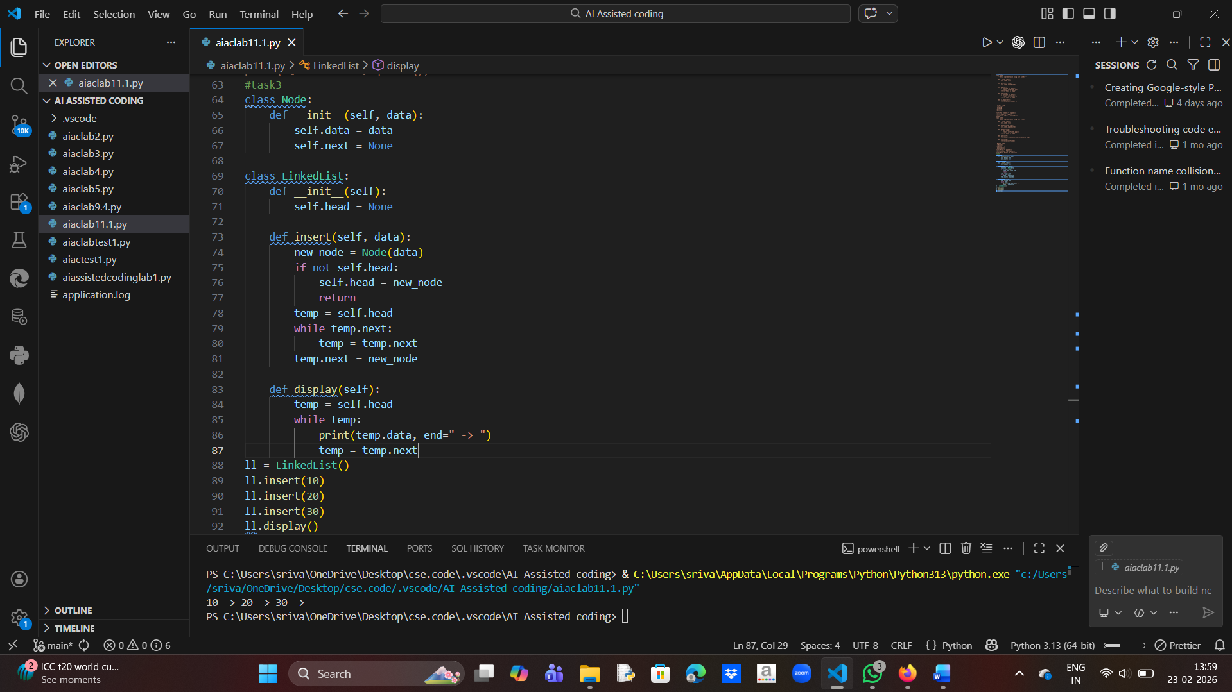

Task 4 – Binary Search Tree
🔹 Prompt:
Create a Binary Search Tree class in Python. Implement recursive insert and inorder traversal.
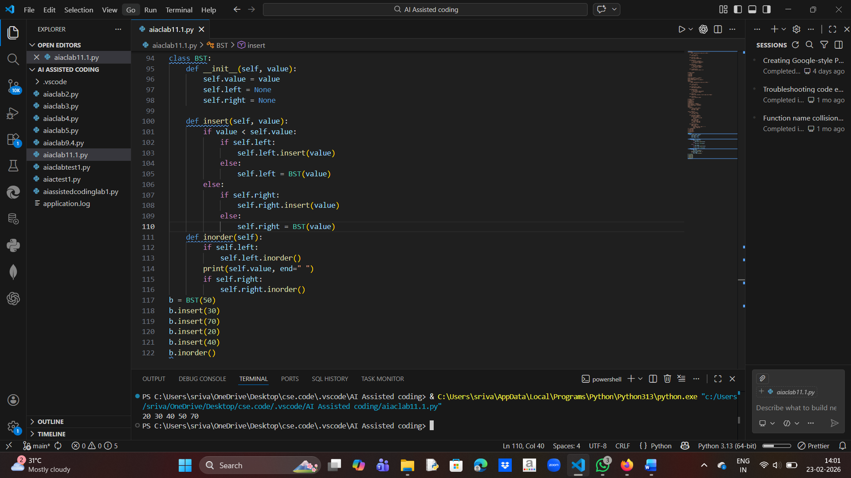

Task 5 – Hash Table
🔹 Promp:
Implement a Hash Table in Python using chaining. Include insert, search and delete methods.
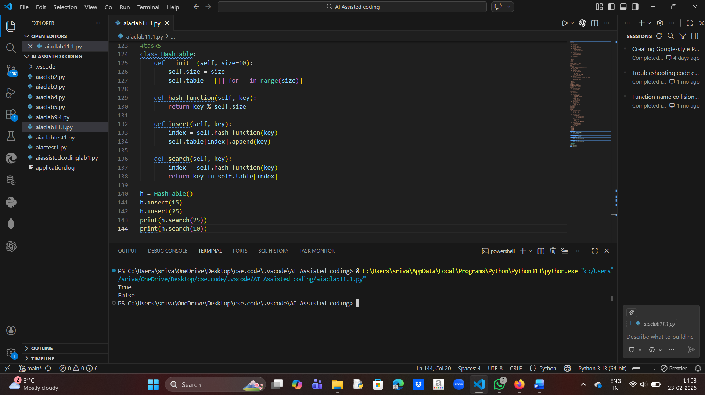

Task 6 – Graph
🔹 Prompt:
Generate a Graph class using adjacency list. Include add_vertex, add_edge and display methods.

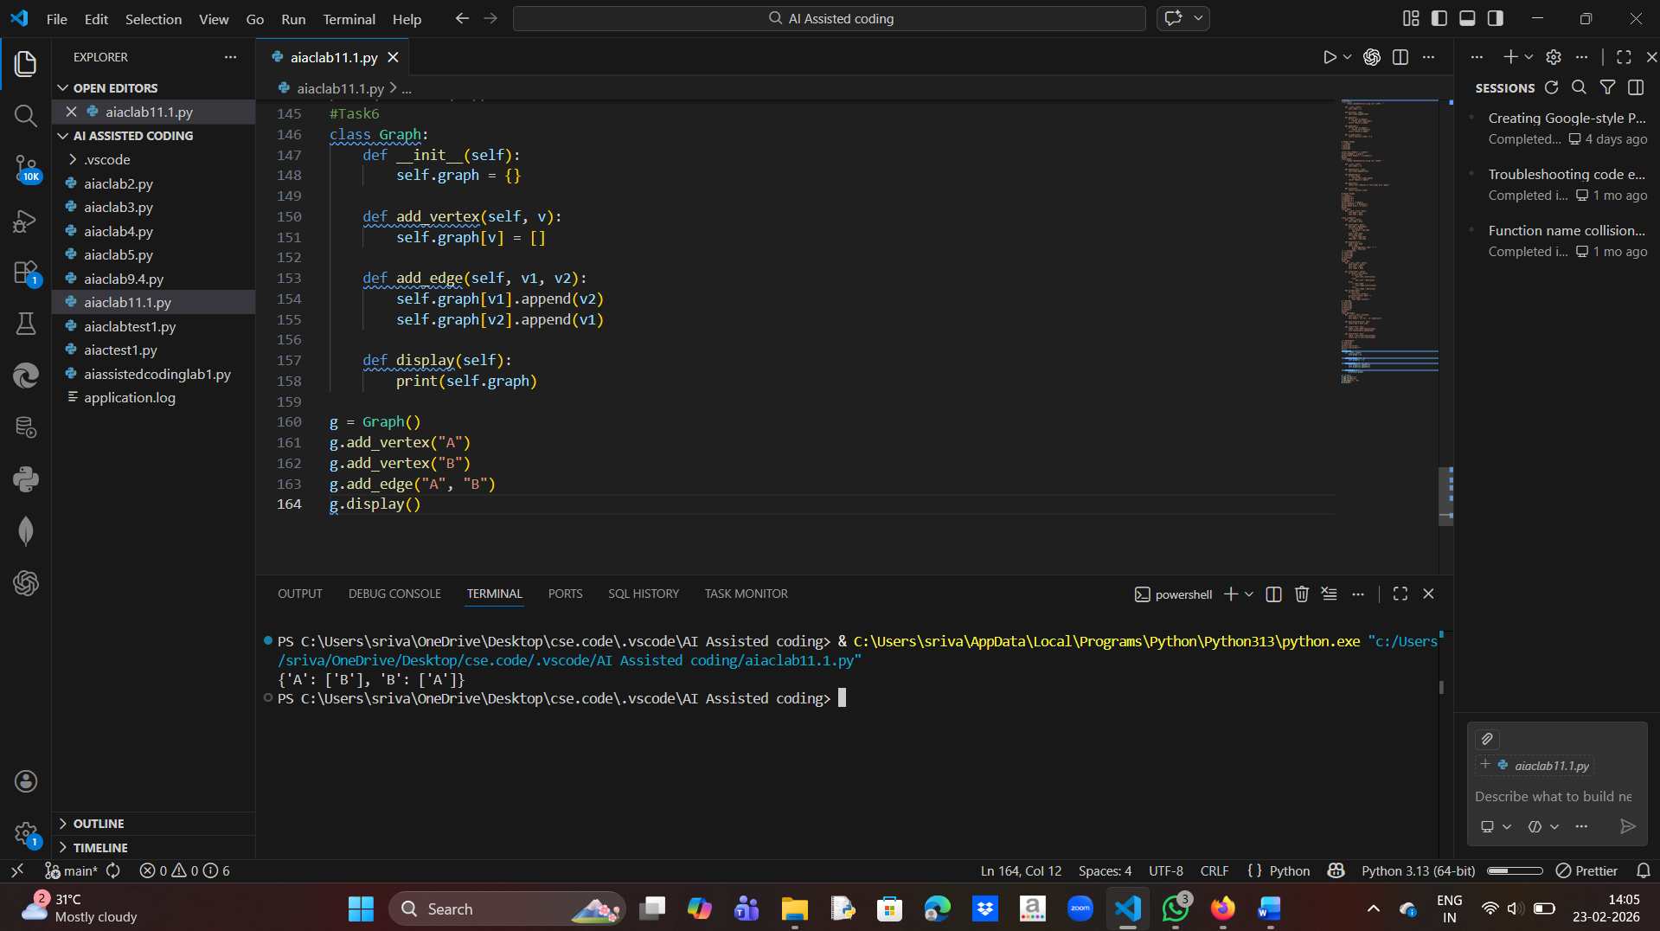
Task 7 – Priority Queue
🔹 Prompt:
Create a Priority Queue using heapq module. Include enqueue and dequeue methods.
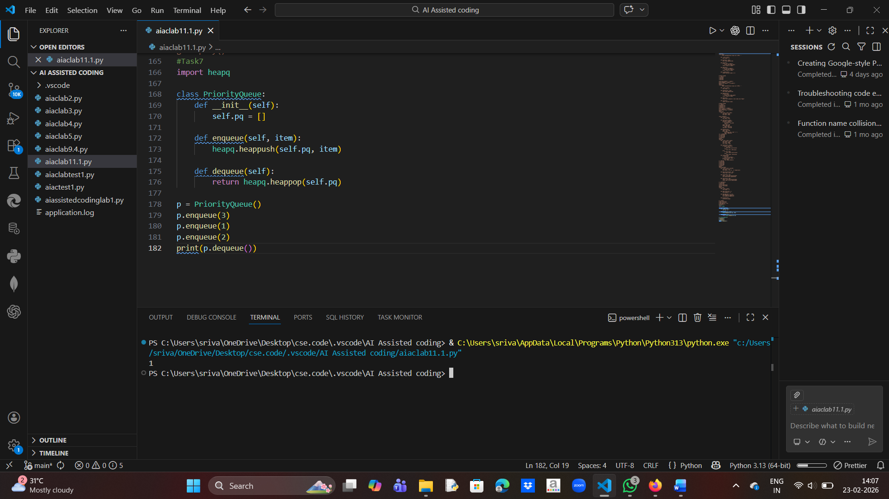

Task 8 – Deque
🔹 Prompt :
Create a Deque using collections.deque. Implement insert and delete from both ends.

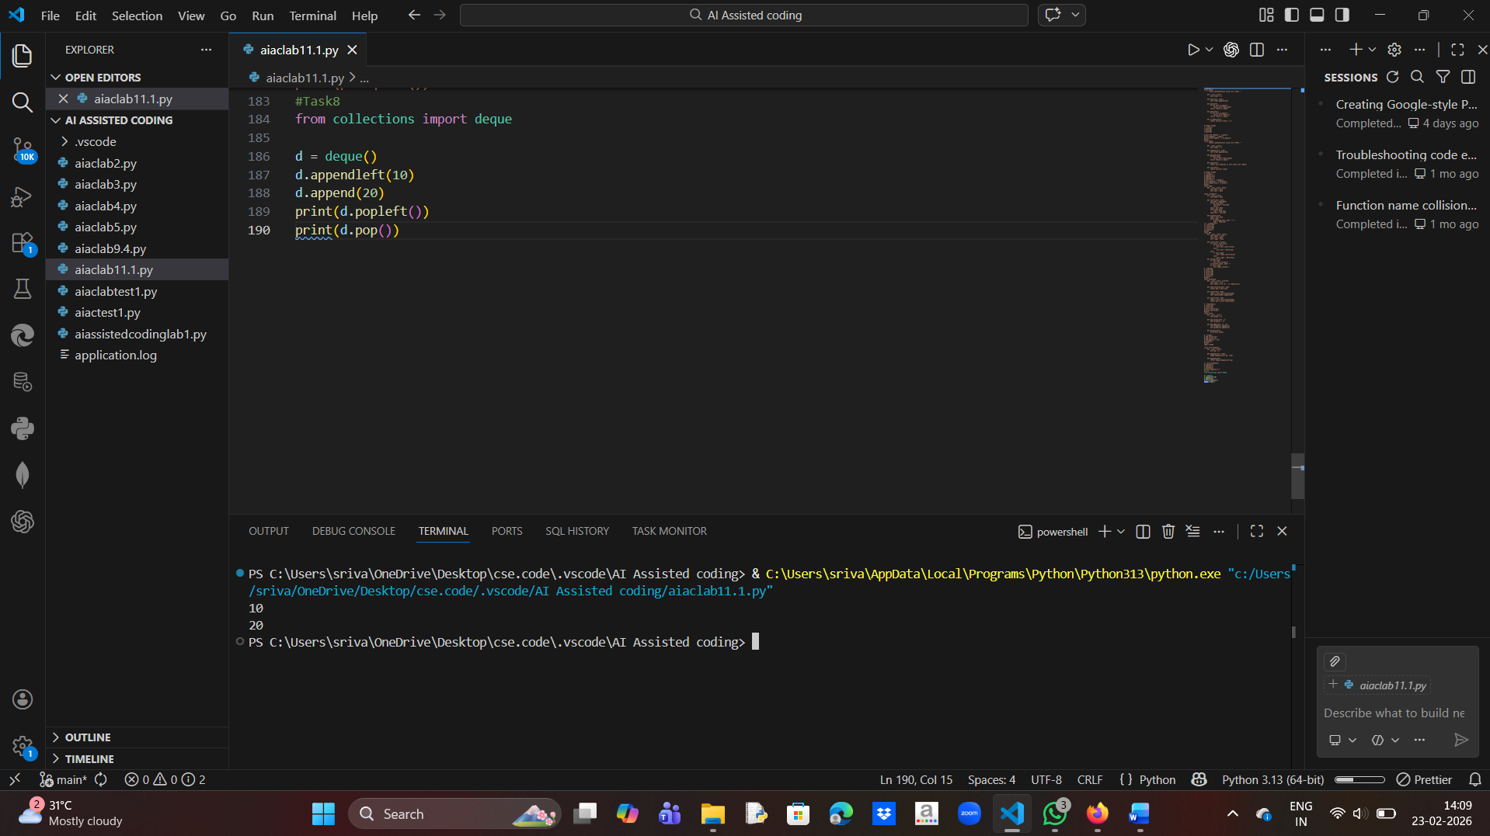

Task 9 – Campus Resource Management System

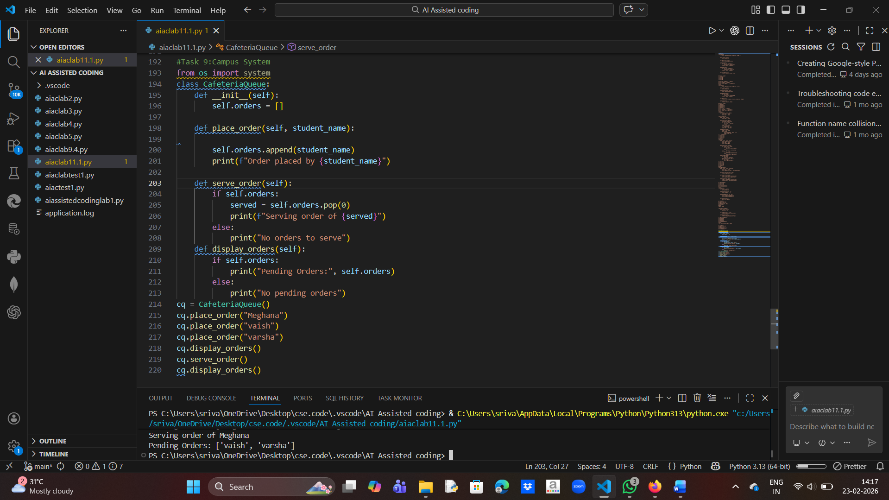

Task 10 – Smart E-Commerce Platform
